


Photo Exercise
Submit photos of real infrastructure and conditions in USVI that either encourage or discourage routine walking, bicycling, and transit use, and share in advance of the webinar.

Examples of the types of photos to capture are below.

Please email your photo(s) by Wednesday, January 27, 2021 to: usviwalkabilityinstitute@gmail.com

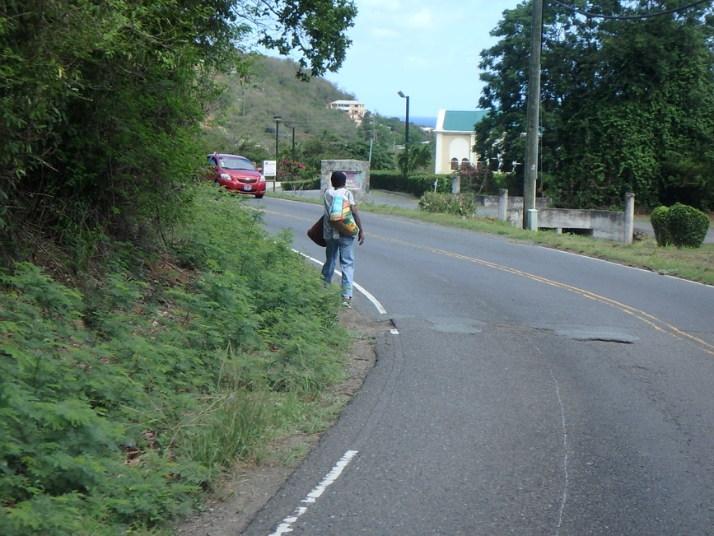
Challenge: No sidewalk or shoulder (Frenchman Bay Rd., St Thomas

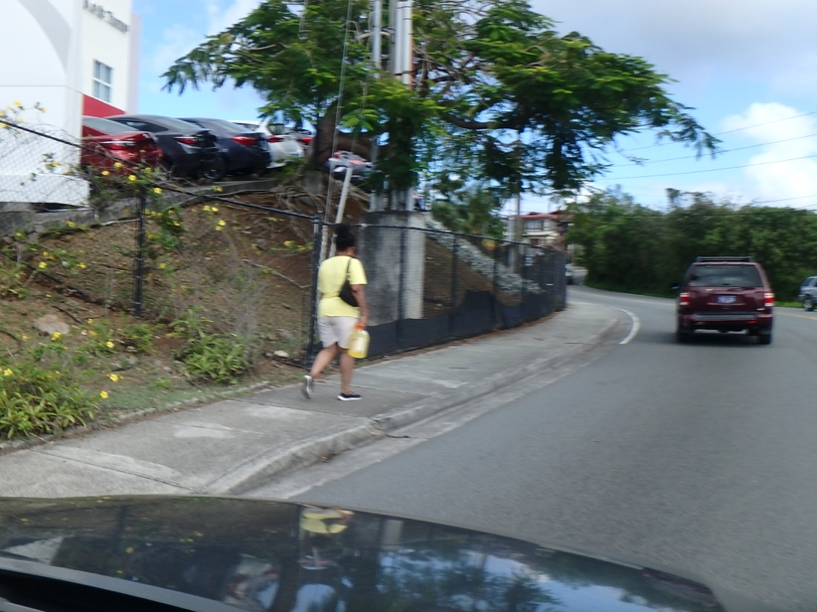
Mixed: Decent sidewalk near Office Max, St. Thomas.
But would like more separation from traffic.

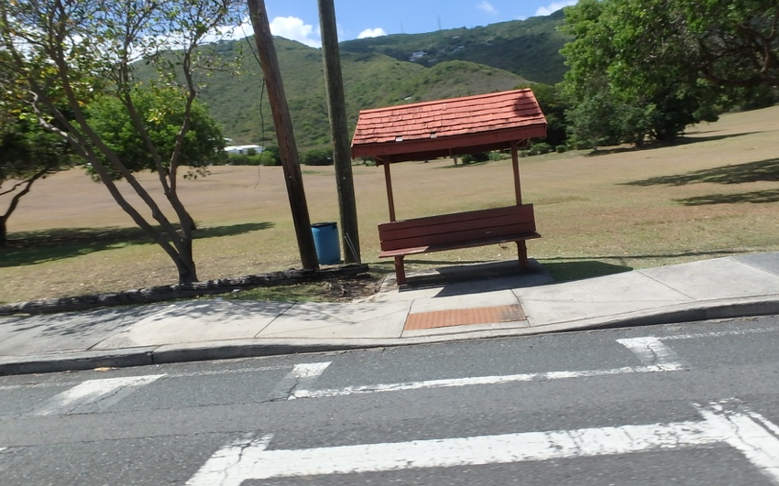
Good: Shaded bus stop, accessible curb ramp, painted crosswalk.
St. Thomas

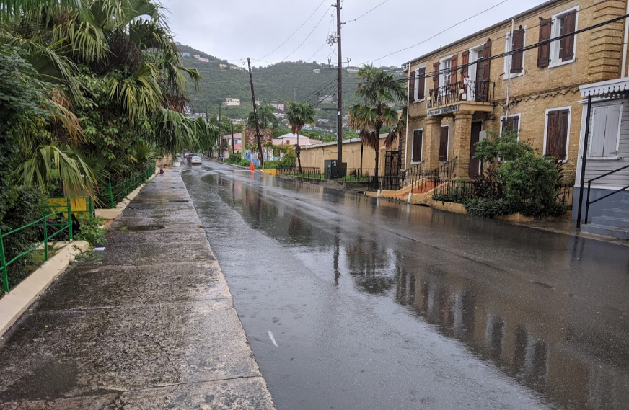
Challenge: Lack of proper drainage can make life difficult for pedestrians. On one side of the road, runoff is flowing next to the sidewalk, which makes the walking experience difficult. On the other side, there is a proper drainage structure, but no sidewalk. St. Thomas

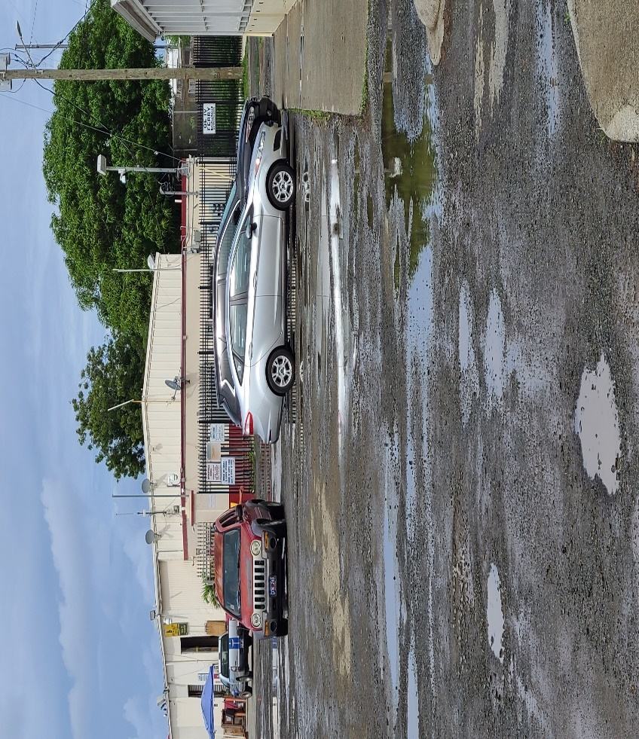
Challenge: After heavy rainstorm, crossing to the ferry entrance is difficult because of potholes. St. Croix

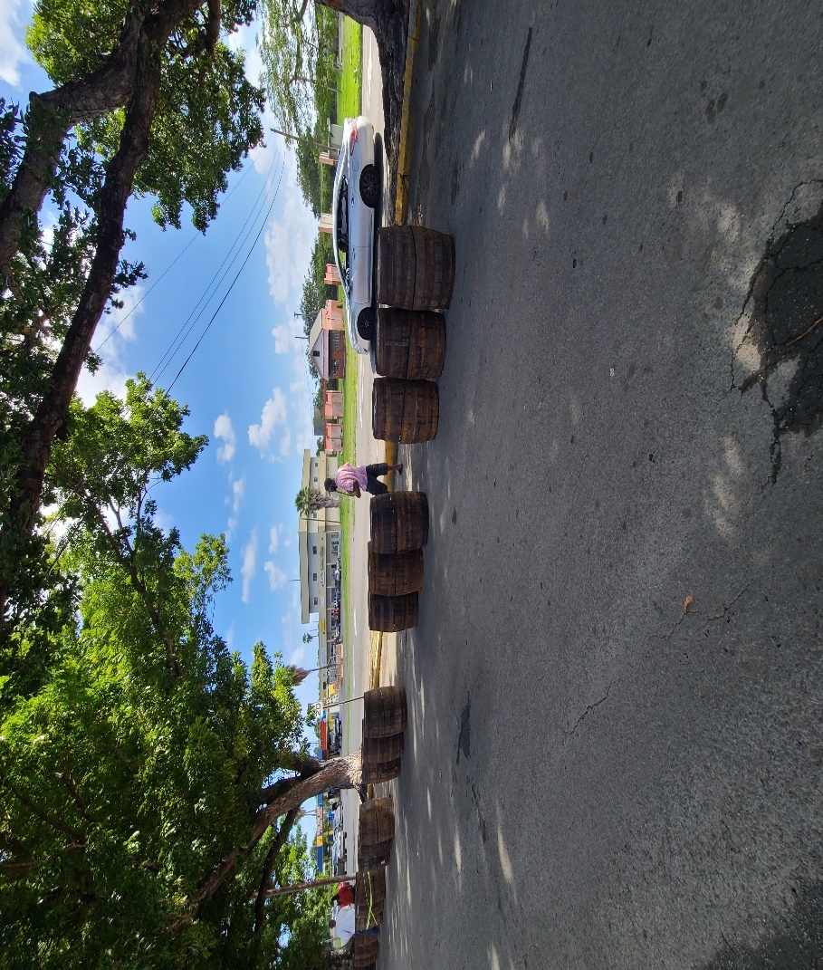
Good: Pedestrian using temporary walkway with barriers on both sides with trees for shading St. Croix

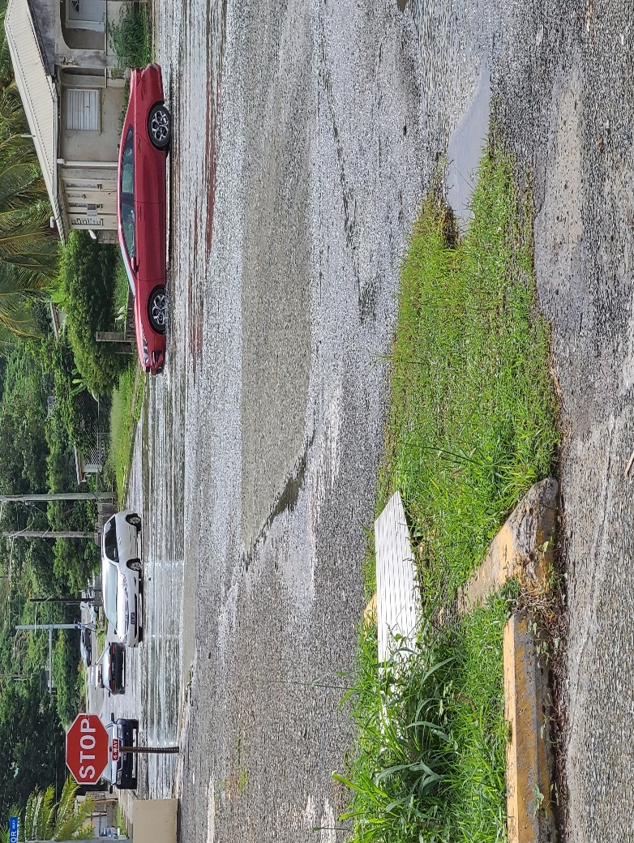
Challenge: Difficult to cross with no sidewalk and floods after heavy rains St. Croix

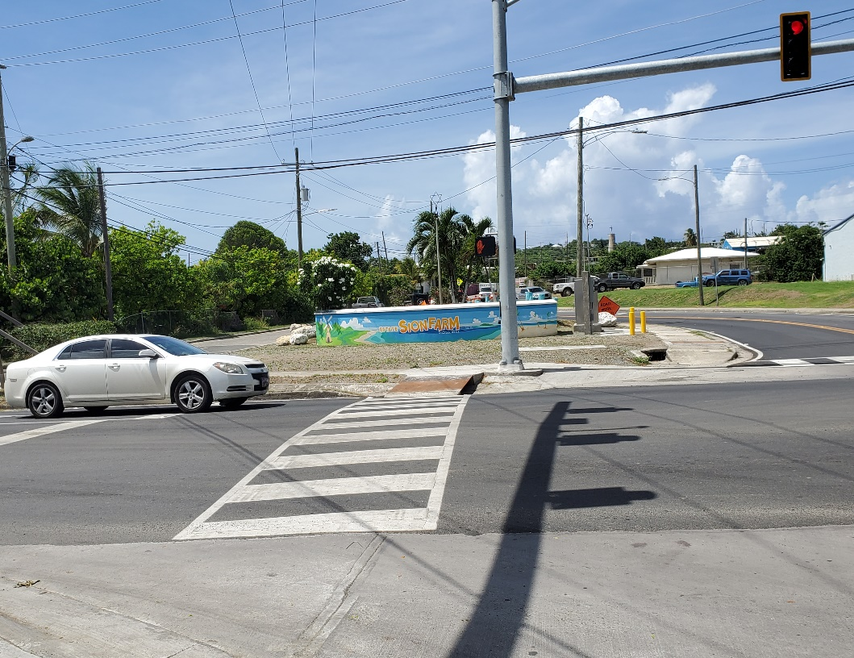
Good: Newly painted crosswalk with a ramp to the sidewalk. St. Croix

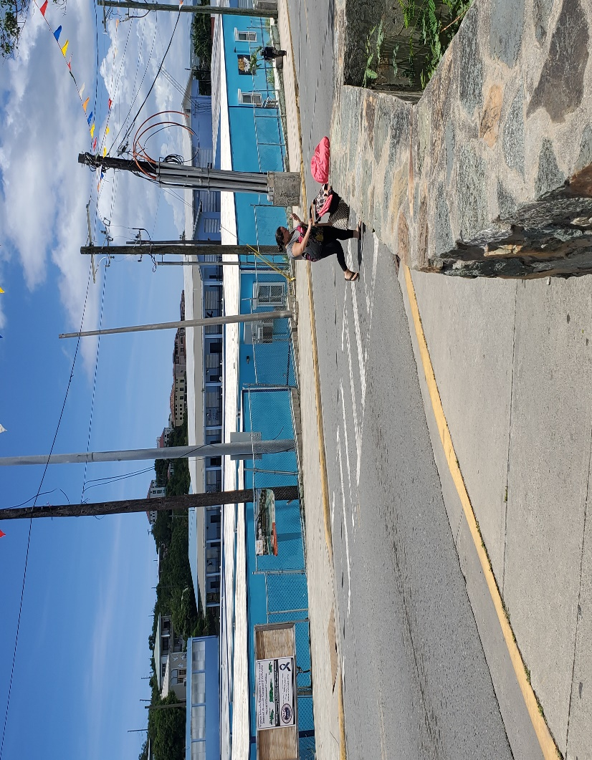
Mixed: Pedestrian with stroller at crosswalk near a turn; other pedestrian using sidewalk near school; St. John

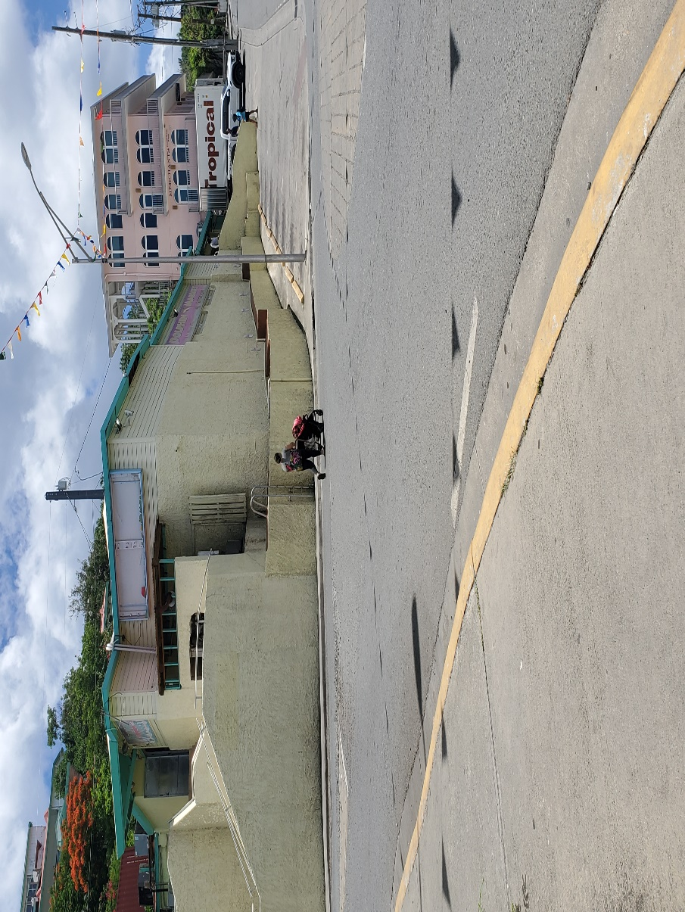
Challenge: Pedestrians using roundabout without sidewalk or crosswalk. St. John

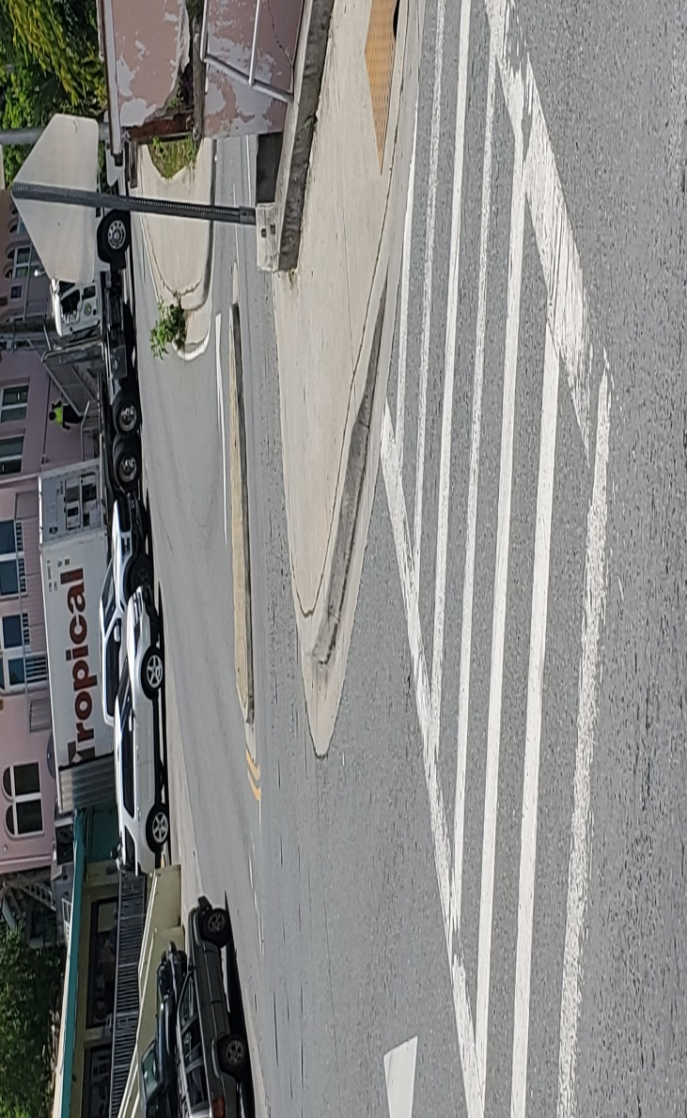
Good: Crosswalk with curb ramp. St. John

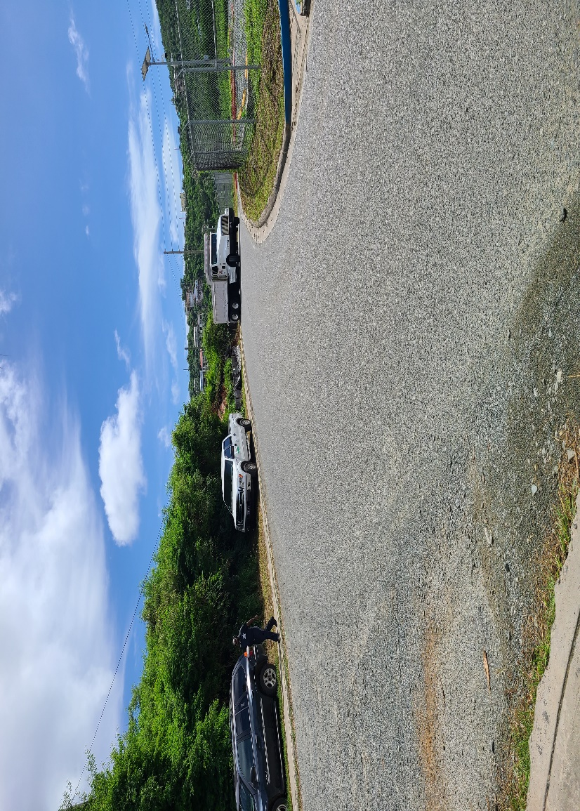
Challenge: Pedestrian using sidewalk with vehicles parked on side of the road. St. John

Email photos with comments to usviwalkabilityinstitute@gmail.com prior to the webinar.

Exercise for webinar: USVI Walkability Institute & UVI webinar: Improving Community Resilience with Sustainable, Walkable Design: An Inter-active Discussion on Friday, January 29, 2021 at 1:00 p.m. AST

